**MECHATRONICS ENGINEERING**

# BMT654C

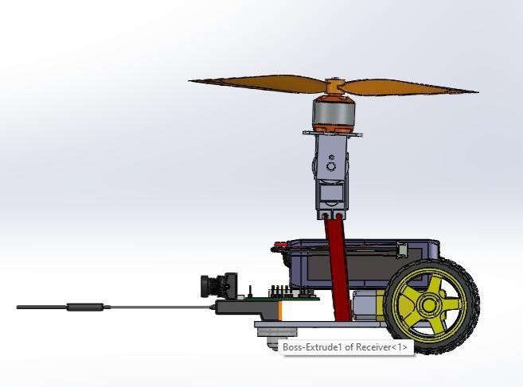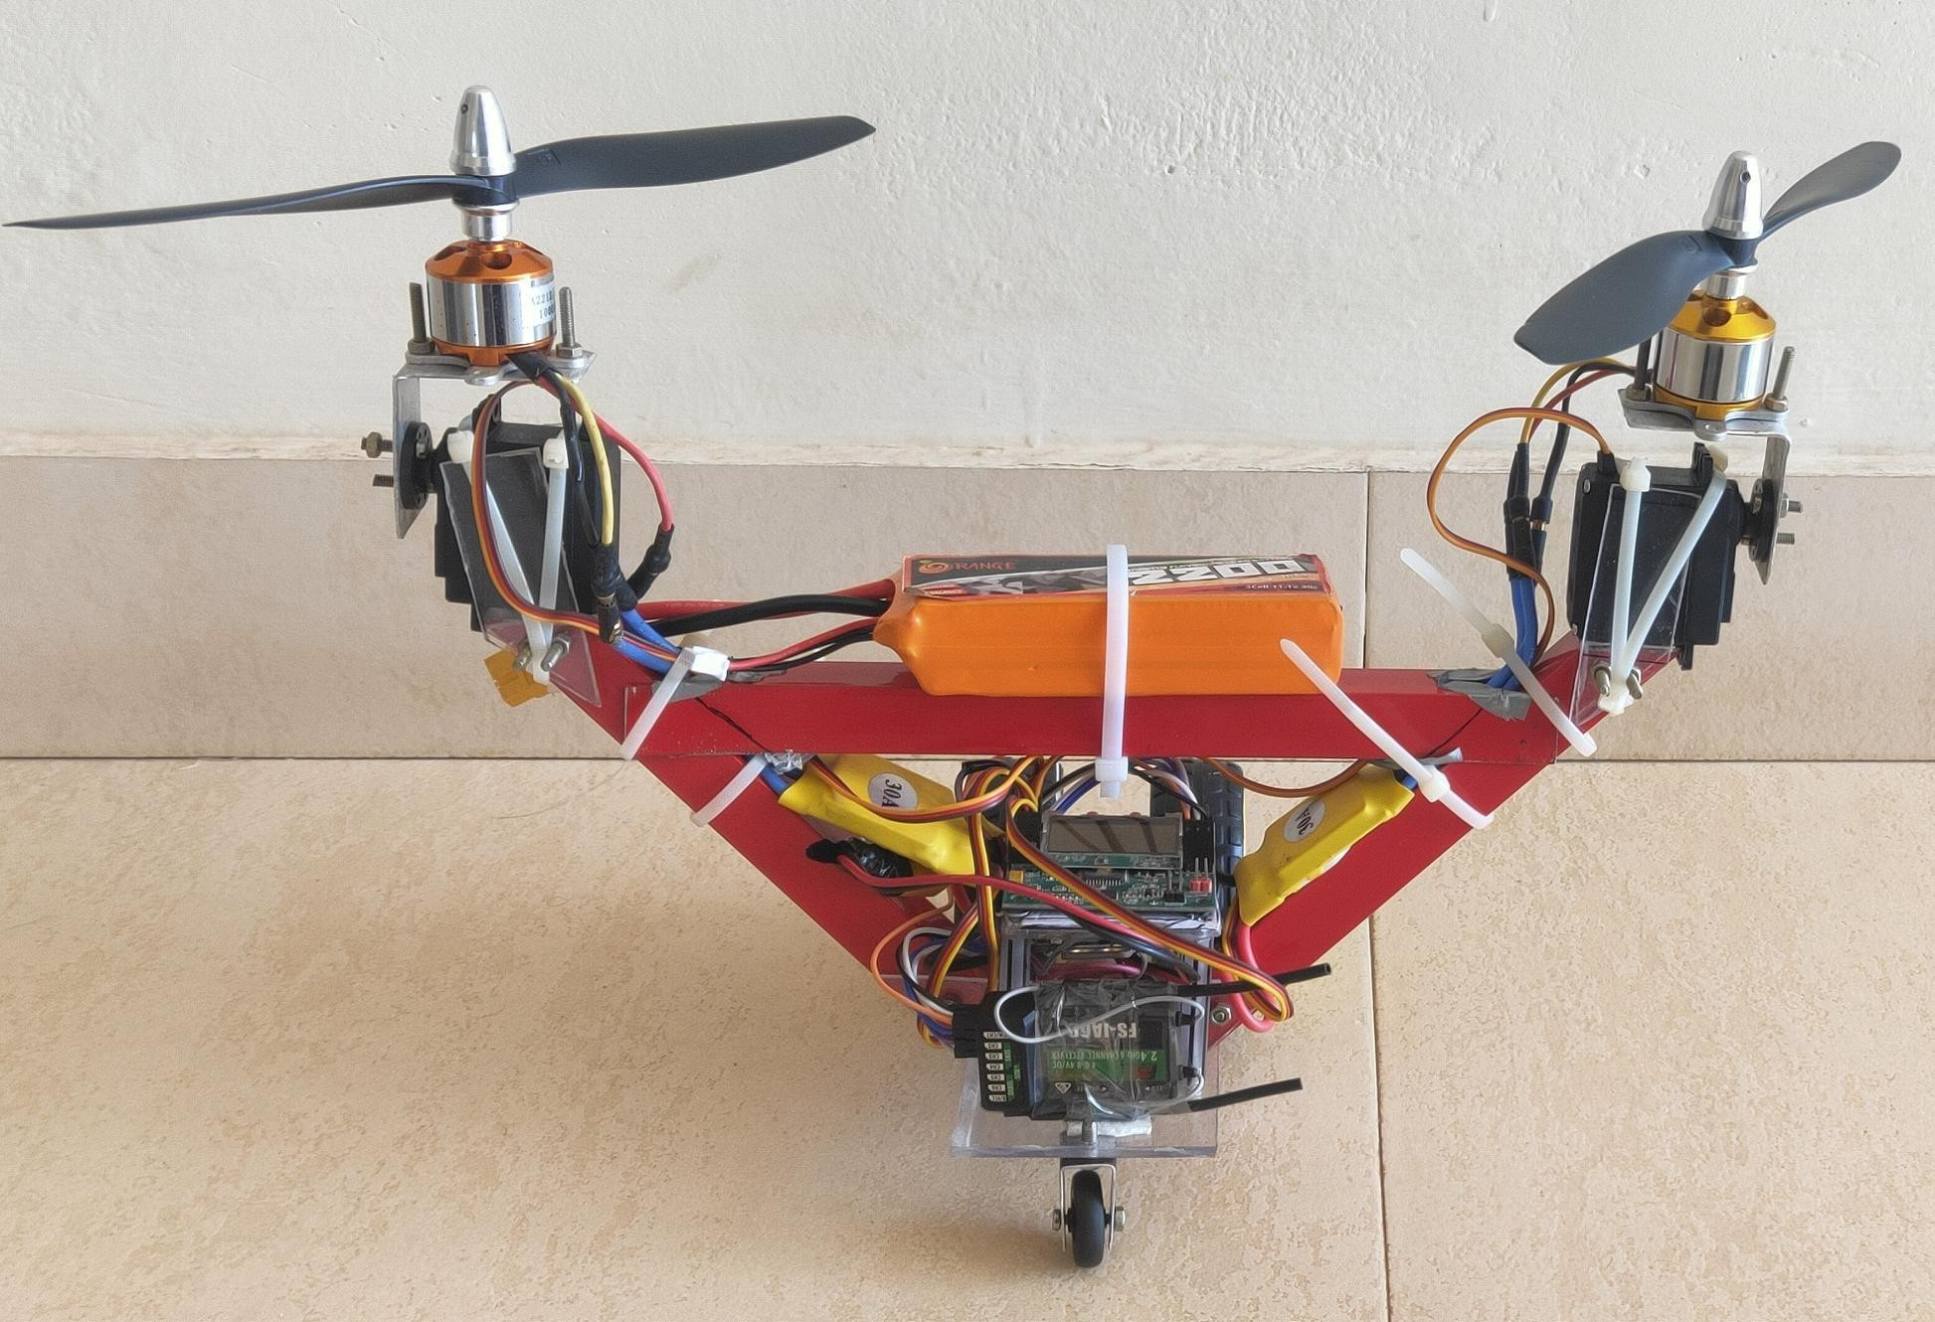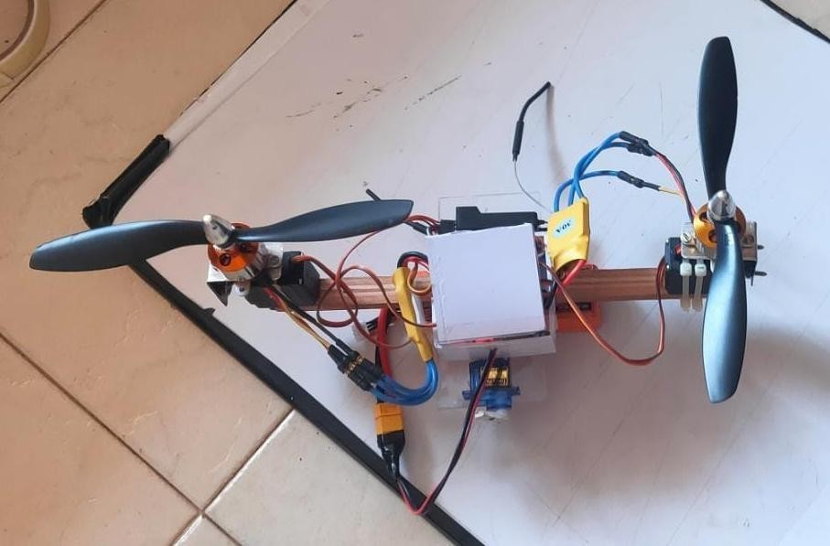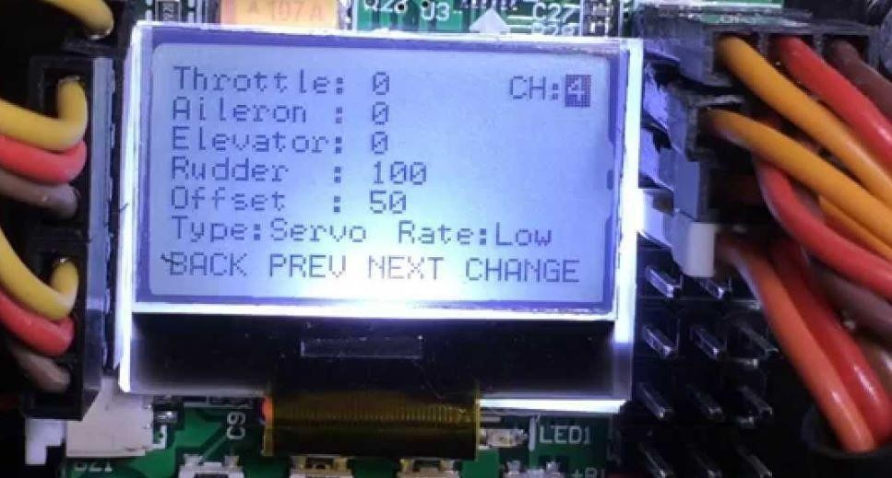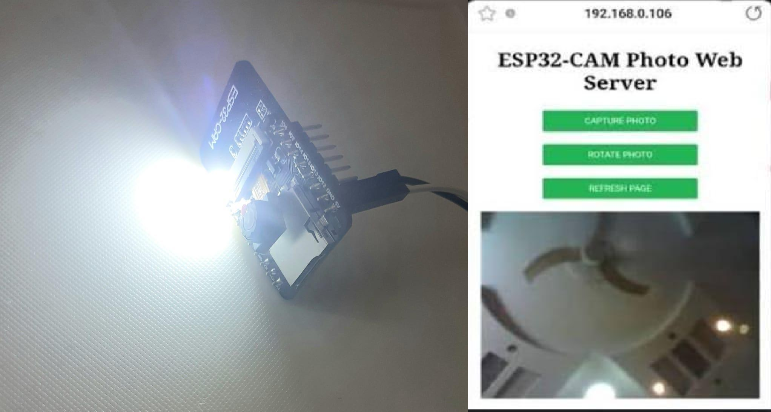

**2. OBJECTIVES**

* **Enhanced Office Security –** Ensure only authorized personnel can access office premises, reducing security risks.
* **Automated Access Control –** Replace manual key-based systems with an RFID-enabled automated system for efficient and contactless entry.
* **Real-time Monitoring & Logging –** Maintain a digital record of all entries and exits, improving attendance tracking and security management.
* **Tag Scanning:** An employee presents their RFID card to the reader at the office entrance.
* **Data Processing:** The RFID reader sends the tag ID to the microcontroller (Arduino/ESP32).
* **Authentication Check:** The microcontroller verifies the scanned ID against a pre-stored database.
* If the ID is valid, the system proceeds to unlock the door.
* If the ID is invalid, access is denied, and a buzzer may alert security.
* **Door Unlocking:** Upon successful authentication, the microcontroller sends a signal to the relay module, which activates the door lock mechanism (servo motor or electric lock).
* **Entry Logging:** The entry time is recorded in a database for attendance and security purposes.
* **Re-locking:** After a preset time delay, the door automatically locks again.

**6. ADVANTAGE**

* **Increased Security –** Prevents unauthorized access and enhances workplace safety.
* **Automated Access Control –** Eliminates the need for manual key-based entry, improving efficiency.
* **Real-time Logging –** Tracks attendance and provides a detailed record of office entries.

**7. APPLICATIONS**

* **Corporate Offices –** Secure employee entry and attendance tracking.
* **Research Labs & Restricted Areas –** Prevent unauthorized access to sensitive locations.
* **Co-working Spaces –** Manage multiple users with RFID-based access.

**8. SUMMARY**

* **Efficient Access Control:** Automates entry using RFID authentication.
* **Secure Access:** Ensures only authorized personnel can enter.
* **Real-Time Logging:** Enhances attendance tracking and security monitoring.
* **Technical Insights:** Provided understanding of RFID technology, microcontroller-based automation, and security system integration.
* **Hands-on Learnings:** Improved understanding of embedded systems, database management, and automation principles.
* **Future Enhancements:** Biometric verification, IoT-based remote access, and AI-powered security analytics.

**3. DESIGN AND WORKING**

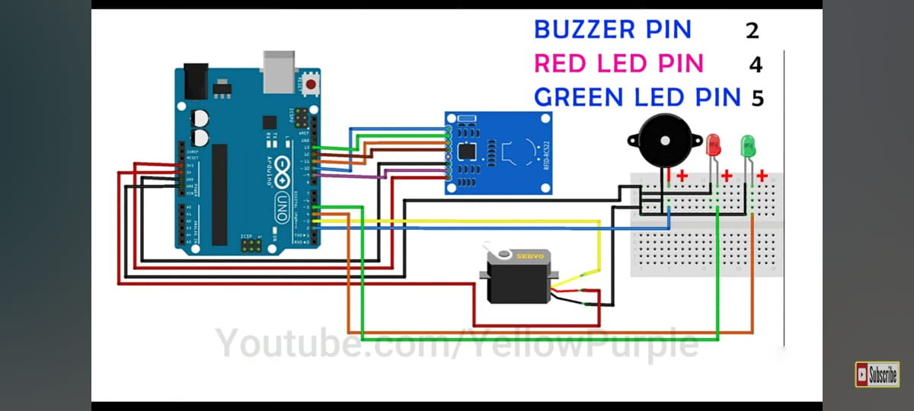

**4. IMAGE OF DEVELOPED MODEL**

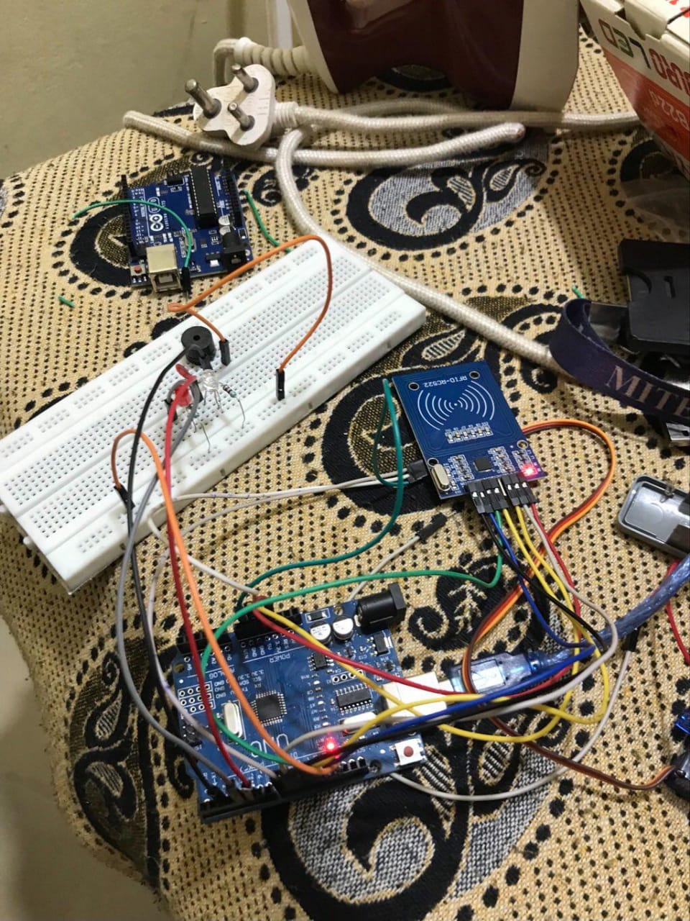

**5. SPECIFICATION TABLE WITH COST**

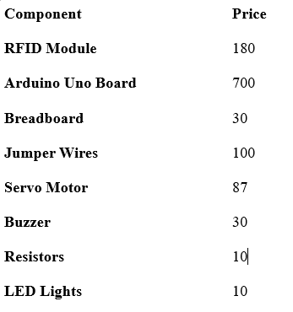

Automatic Door using RFID

*Heramba R Naik , Deeksha L J , Pavan Kulal , Zubair*

1. **INTRODUCTION**

* **Secure Access Control:** Enhances security with real-time authentication and automated door control.
* **RFID Technology:** Utilizes Radio-Frequency Identification for efficient and secure access.
* **RFID Technology:** Utilizes Radio-Frequency Identification for efficient and secure access.
* **Real-Time Logging:** Provides accurate records of office entries and exits for attendance tracking.
* **Efficient Entry Process:** Streamlines entry with automated door mechanism.
* **Scalable Solution:** Can be integrated with existing office infrastructure.
* **Cost-Effective:** Offers a viable solution for modern office environments.



**MANGALORE INSTITUTE OF TECHNOLOGY & ENGINEERING**

(A Unit of Rajalaxmi Education Trust®, Mangalore)

Autonomous Institute affiliated to VTU, Belagavi, Approved by AICTE, New Delhi Accredited by NAAC with A+ Grade & ISO 9001:2015 Certified Institution